Primary Source Activity
Two Accounts of Cholula

In this writing assignment we are venturing outside the region of United States to examine one of the first interactions between Europeans and Indigenous societies. Using primary sources, you will write a brief 5 paragraph essay that examines one event from multiple historical perspectives. This essay is also a chance for you to get back into the academic mindset and demonstrate your already established skills.

CLASS ASSIGNMENT
Individually read the following two accounts of the Battle of Cholula. Remember to underline the author’s perceptions of different groups of people. After the first account, you will split up into groups and complete the worksheet. Your group will repeat the process for the second source. We will review the contrasting accounts as a class.

HOMEWORK ASSIGNMENT
You will be responsible for writing an essay comparing and contrasting the two accounts of the Battle of Cholula. Use quotes and specific examples. In your analysis discuss how the author views the Spanish, the Cholulans and the Tlaxcaltecas. Your essay will be approximately one and half pages in length (double spaced).

CITATION
- “This is a quote” (Diaz).
- I am paraphrasing a quote (Broken Spears)
CATEGORY  -5 points each | Exceeds the Standard (4-5 points) | Meets the Standard (3 points) | Does Not Meet the Standard (1-2 points)
Purpose & Supporting Details | The paper compares and contrasts items clearly, points to specific examples to illustrate the comparison, and includes only the information relevant to the comparison. | The paper compares and contrasts items clearly, but the supporting information is general. The paper includes only the information relevant to the comparison. | The paper compares and contrasts items clearly, but the supporting information is incomplete, and may include information that is not relevant to the comparison.
Organization & Structure | Introduction and Conclusion Paragraph  The paper breaks the information into point-by-point or block-by-block structure. It follows a consistent order when discussing the comparison. | The paper breaks the information into point-by-point structure or block-by-block, but may not follow a consistent order when discussing the comparison. | Organizational pattern not identifiable. Some details are not in a logical or expected order, and this distracts the reader.
Transitions | The paper moves smoothly from one idea to the next and uses transition words and subtle transitions to show relationships between ideas. | The paper moves from one idea to the next, but may lack or misuse transition words to show relationships between ideas. | Transitions may be missing; connections between ideas are fuzzy or illogical.
Grammar & Spelling (Conventions) | Writer makes no errors in grammar or spelling that distract the reader from the content. | Writer makes 1-2 errors in grammar or spelling that distract the reader from the content. | Writer makes several errors in grammar or spelling that distract the reader from the content.

BACKGROUND: THE HISTORICAL CHARACTERS

Montezuma- The ruler of the Aztec empire at the time of the conquest. He lived in Tenochtitlan and is not present at the Battle of Cholula

The Cholulas- A tribe of people controlled by the Aztec Empire. They are rivals with the Tlaxcaltecans

Tlaxcaltecans- A tribe that was once under control of the Aztecs. They allied with Cortez to help him defeat the Aztec Empire.

Cempoalans- One of the first indigenous groups that Cortes and his men allied with. Some have accompanied the Spanish to Tlaxcalteca

Hernan Cortez (Cortes)- A Spanish ‘conquistador’ credited with defeating the Aztec empire and founding New Spain (present day Mexico). He is occasionally refered to as ‘Our Captain’ in Diaz’s text.

La Malinche/Dona Marina – From the Mexican Gulf Coast, Malinche became Cortez’s personal translator. She would also become Cortez’s lover.

Bernal Diaz- Diaz was a conquistador and member of Cortez’s small army during the Aztec Conquest. Thirty years after the conquest, he wrote a book of his account of the conquest, The True History of the Conquest of New Spain.

Caciques- The Spanish word for the leader of a Mexican tribe, there are many caciques

Papas- The Spanish name for priests in the Aztec world

Codex Florentino- Twenty years after the conquest, Franciscan Friar, Bernadino de Sahagun, along with his Aztec students, travelled around New Spain and gathered native accounts and drawings of the Spanish conquest.

Adapted from experts of Broken Spears- The Aztec Account of the Conquest of Mexico

Background
Despite the efforts of Motecuhzoma's envoys to keep the Spaniards from approaching Tenochtitlan, Cortes decided to march inland. Cortes and his men develop an alliance with the Tlazcaltecas. The joined forces decided to go to another people, the Cholulans. The reason for the forces going to Cholula and the reasons behind the battle/massacre are still under dispute.

An Aztec Account Recorded By Friar Bernadino de Sahagun

Intrigues Against Cholula
At this time the Tlaxcaltecas were enemies of Cholula. They feared the Cholultecas; they envied and cursed them; their souls burned with hatred for the people of Cholula. This is why they brought certain rumors to Cortes, so that he would destroy them. They said to him: "Cholula is our enemy. It is an evil city. The people are as brave as the Aztecs and they are the Aztecs' friends."
When the Spaniards heard this, they marched against Cholula. They were guided and accompanied by the Tlaxcaltecas and the chiefs from Cempoala, and they all marched in battle array.'
The Massacre at Cholula
When they arrived, the Tlaxcaltecas and the men of Cholula called to each other and shouted greetings. An assembly was held in the courtyard of the god, but when they had all gathered together, the entrances were closed, so that there was no way of escaping.
Then the sudden slaughter began: knife strokes, and sword strokes, and death. The people of Cholula had not foreseen it, had not suspected it. They faced the Spaniards without weapons, without their swords or their shields. The cause of the slaughter was treachery. They died blindly, without knowing why, because of the lies of the Tlaxcaltecas.
And when this had taken place, word of it was brought to Motecuhzoma. The messengers came and departed, journeying back and forth between Tenochtitlan and Cholula. The common people were terrified by the news; they could do nothing but tremble with fright. It was as if the earth trembled beneath them, or as if the world were spinning before their eyes, as it spins during a fit of vertigo....
When the massacre at Cholula was complete, the strangers set out again toward the City of Mexico. They came in battle array, as conquerors, and the dust rose in whirlwinds on the roads. Their spears glinted in the sun, and their pennons fluttered like bats. They made a loud clamor as they marched, for their coats of mail and their weapons clashed and rattled. Some of them were dressed in glistening iron from head to foot; they terrified everyone who saw them.
Their dogs came with them, running ahead of the column. They raised their muzzles high; they lifted their muzzles to the wind. They raced on before with saliva dripping from their jaws.

A depiction of the Chululan Massacre drawn by an unknown indigenous artist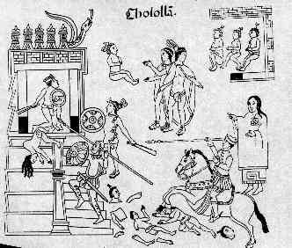

Bernal Diaz’s Account of the Battle of Cholula
Excerpts from the Conquest of New Spain

At this point Cortes had already allied with the Tlexcalans. According to Diaz, the Spanish had sent out a message to the Cholulans asking them to become allies as well. The Spanish wanted the Cholulan Chiefs to come to Tlexcalan territory to discuss a strategy to defeat Montezuma. The Cholulans refuse to meet with the Spanish.

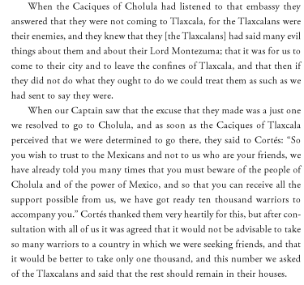

Cortes and His men arrive at Cholula. While the Cholulan Caciques welcome them into their village and swear their allegiance to Cortes, Diaz feels as if there is something suspicious going on. The Cholulans are acting awkward and there are rumors that Montezuma has sent envoys to Cholula to help them defeat the Spaniards. A few Cempoalan allies warn Cortes that they have discovered the Cholulans prepping for a battle by creating ditches in a nearby field. Cortes calls a meeting with the Cholulan Caciques and kindly reminds them that they had made an allegiance with the Spaniards not Montezuma, if they betray this allegiance they will be punished. The Cholulan Caciques deny their betrayal but Cortes is not convinced. The next day he gathers the Cholulans in the temple and proclaims that the Cholula has broken its treaty.
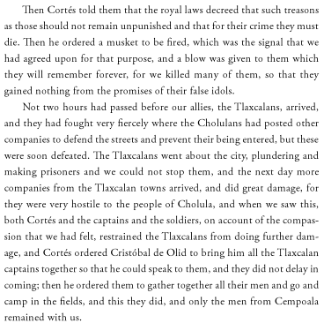

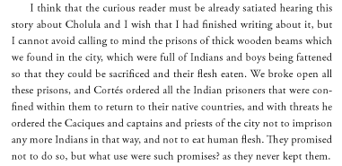

Analysis of The Aztec Account

1) How does the author view the Tlexcaltecans?

2) How does the author view the Spaniards?

3) According to the author, were the Spaniards looking to fight the Cholulans or create an alliance?

4) How did the author describe the battle/massacre? Who was fighting and how were they fighting?

5) Did the drawing of the event agree with the author’s perspective of the event?

Analysis of Bernal Diaz’s Account

1) How does the author view the Tlexcaltecans?

2) How does the author view the Spaniards?

3) According to the author, were the Spaniards looking to fight the Cholulans or did they intend to make an alliance?

4) Diaz argued that the battle was necessary for a few reasons. What was the reason he gave before describing the battle? What was another reason he gave after he described the battle?

5 Paragraph Format

I: Introduction/Thesis:
- Provides context/interesting opening to the essay
- Illustrates a specific thought, rather than merely repeating the question.
- Answers the question directly (often by identifying key phrases / verbs in the question)
- Drives the essay by providing a framework for the student’s entire argument

II: Body Paragraph #1:
- Topic Sentence is direct and effective
- Develop an aspect of one’s thesis and connect back to that thesis.
- Utilizes both the documents and knowledge gained from the readings and class
- Conclusion of the paragraph links back to the thesis and transitions to the next paragraph

II: Body Paragraph #2:
- Topic Sentence is direct and effective
- Develop an aspect of one’s thesis and connect back to that thesis.
- Utilizes both the documents and knowledge gained from the readings and class
- Conclusion of the paragraph links back to the thesis and transitions to the next paragraph

III: Inclusion of Documents / Quotations:
- Proper Citation: …the Stamp Act” (Document B).
    - Quotations are introduced: Franklin argues, “[quotation.]”.

IV: Conclusion:
- Conclusions should review the material and provide a final interesting thought

