The Mayflower Compact
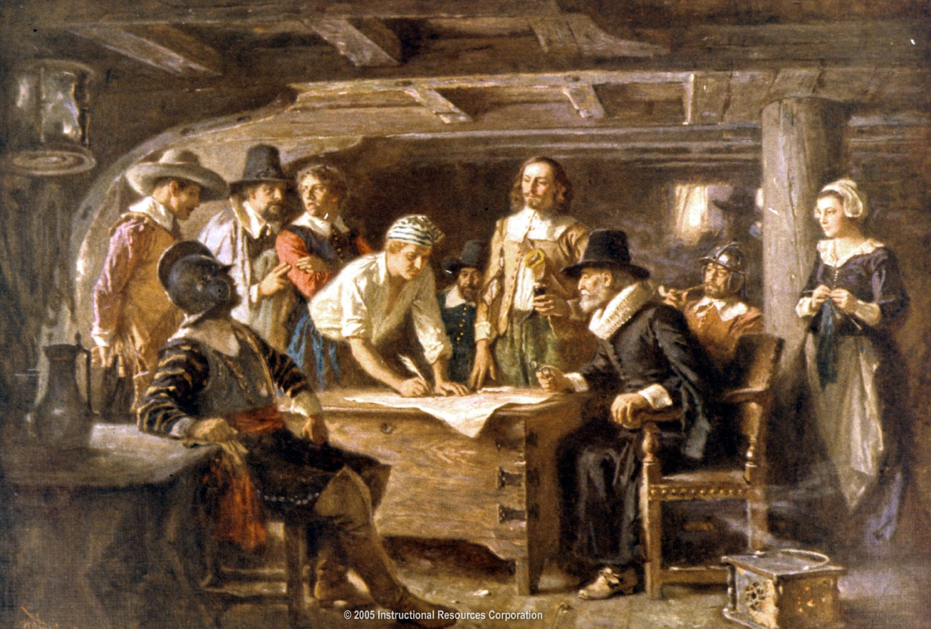

An agreement reached by the Pilgrims on the ship the Mayflower in 1620, just before they landed at Plymouth Rock. The Mayflower Compact bound them to live in a civil society according to their own laws. It remained the fundamental law of their colony of Plymouth until the colony was absorbed into Massachusetts in the late seventeenth century.

Mayflower Compact : 1620

Agreement Between the Settlers at New Plymouth : 1620
IN THE NAME OF GOD, AMEN. We, whose names are underwritten, the Loyal Subjects of our dread Sovereign Lord King James, by the Grace of God, of Great Britain, France, and Ireland, King, Defender of the Faith, &c. Having undertaken for the Glory of God, and Advancement of the Christian Faith, and the Honour of our King and Country, a Voyage to plant the first Colony in the northern Parts of Virginia; Do by these Presents, solemnly and mutually, in the Presence of God and one another, covenant and combine ourselves together into a civil Body Politick, for our better Ordering and Preservation, and Furtherance of the Ends aforesaid: And by Virtue hereof do enact, constitute, and frame, such just and equal Laws, Ordinances, Acts, Constitutions, and Officers, from time to time, as shall be thought most meet and convenient for the general Good of the Colony; unto which we promise all due Submission and Obedience. IN WITNESS whereof we have hereunto subscribed our names at Cape-Cod the eleventh of November, in the Reign of our Sovereign Lord King James, of England, France, and Ireland, the eighteenth, and of Scotland the fifty-fourth, Anno Domini; 1620.
Mr. John Carver,
Mr. William Bradford,
Mr Edward Winslow,
Mr. William Brewster.
Isaac Allerton,
Myles Standish,
John Alden,
John Turner,
Francis Eaton,
James Chilton,
John Craxton,
John Billington,
Joses Fletcher,
John Goodman,
Mr. Samuel Fuller,
Mr. Christopher Martin,
Mr. William Mullins,
Mr. William White,
Mr. Richard Warren,
John Howland,
Mr. Steven Hopkins,
(1) the English Church shall be free, and shall have its rights undiminished, and its liberties unimpaired.

The Magna Carta
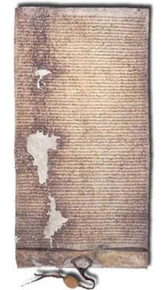
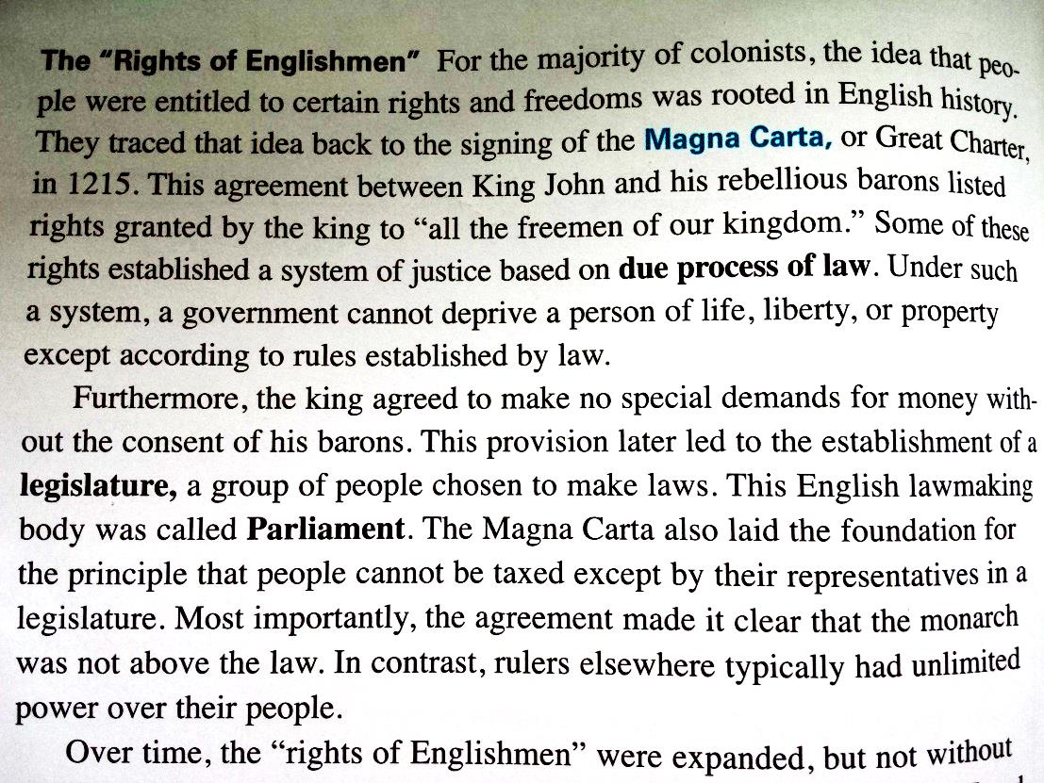

Magna Carta
(9) Neither we nor our officials will seize any land or rent in payment of a debt, so long as the debtor has movable goods sufficient to discharge the debt.
(23) No town or person shall be forced to build bridges over rivers except those with an ancient obligation to do so.
28) No constable or other royal official shall take corn or other movable goods from any man without immediate payment, unless the seller voluntarily offers postponement of this.
(30) No sheriff, royal official, or other person shall take horses or carts for transport from any free man, without his consent.
(38) In future no official shall place a man on trial upon his own unsupported statement, without producing credible witnesses to the truth of it.
(39) No free man shall be seized or imprisoned, or stripped of his rights or possessions, or outlawed or exiled, or deprived of his standing in any other way, nor will we proceed with force against him, or send others to do so, except by the lawful judgment of his equals or by the law of the land.
(40) To no one will we sell, to no one deny or delay right or justice.
(42) In future it shall be lawful for any man to leave and return to our kingdom unharmed and without fear, by land or water, preserving his allegiance to us, except in time of war, for some short period, for the common benefit of the realm. People that have been imprisoned or outlawed in accordance with the law of the land, people from a country that is at war with us, and merchants - who shall be dealt with as stated above - are excepted from this provision.
(63) IT IS ACCORDINGLY OUR WISH AND COMMAND that the English Church shall be free, and that men in our kingdom shall have and keep all these liberties, rights, and concessions, well and peaceably in their fulness and entirety for them and their heirs, of us and our heirs, in all things and all places for ever.

The English Bill of Rights
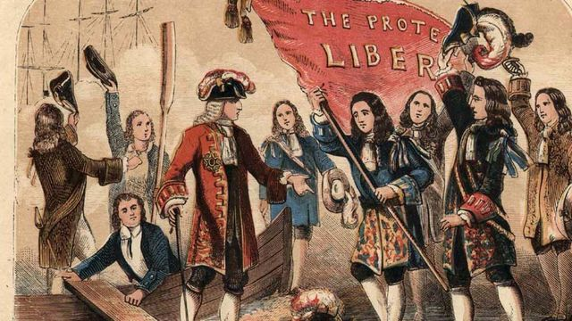

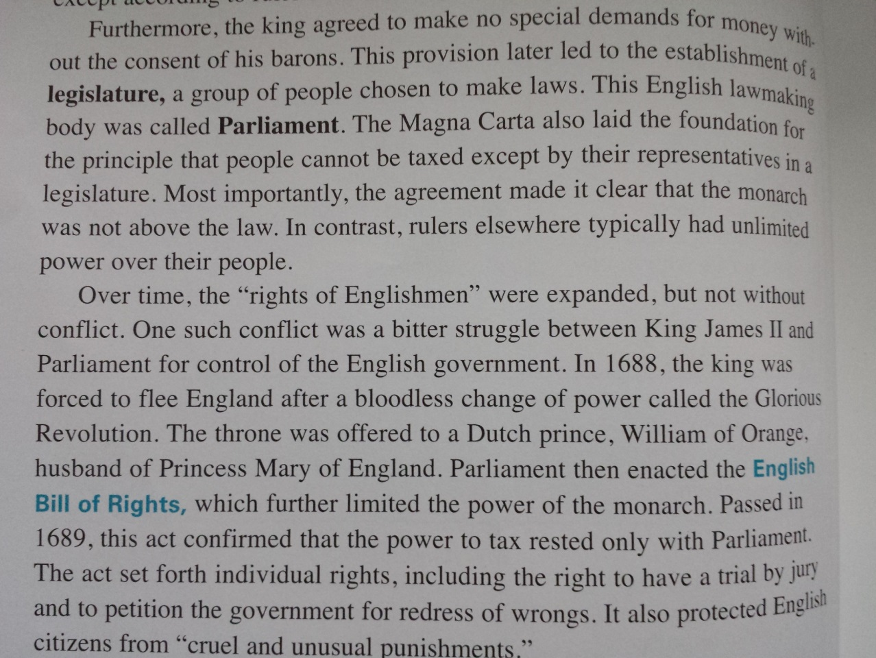

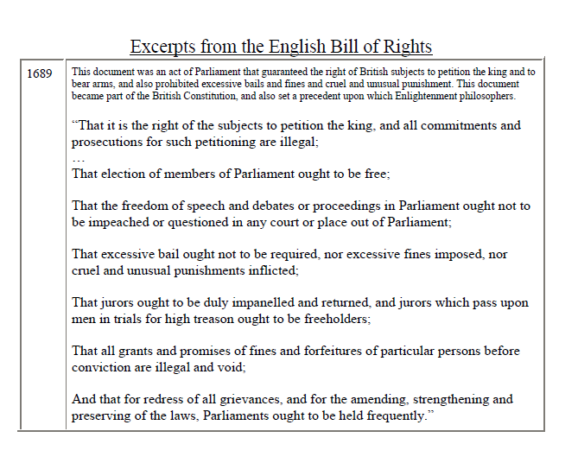

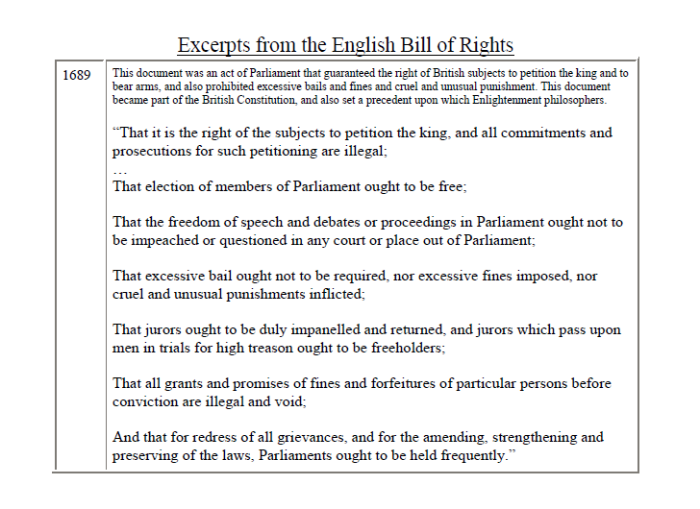

The Albany Plan

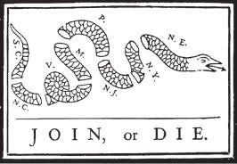

In the 1750’s England and France were engaged in a 7 years war.. In June 1754 delegates from most of the northern colonies and representatives from the Six Iroquois Nations met in Albany, New York. There they adopted a "plan of union" drafted by Benjamin Franklin of Pennsylvania. Under this plan each colonial legislature would elect delegates to an American continental assembly presided over by a royal governor.
The plan is noteworthy in several respects. First of all, Franklin anticipated many of the problems that would beset the government created after independence, such as finance, dealing with the Indian tribes, control of commerce, and defense. In fact, it contains the seeds of true union, and many of these ideas would be revived and adopted in Philadelphia more than thirty years later.
After the plan was unveiled, the Crown did not push it since British officials realized that, if adopted, the plan could create a very powerful entity that His Majesty's Government might not be able to control

Albany Plan of Union
It is proposed that humble application be made for an act of Parliament of Great Britain, by virtue of which one general government may be formed in America, including all the said colonies, within and under which government each colony may retain its present constitution, except in the particulars wherein a change may be directed by the said act, as hereafter follows.
1. That the said general government be administered by a President-General, to be appointed and supported by the crown; and a Grand Council, to be chosen by the representatives of the people of the several Colonies met in their respective assemblies.
2. That within -- months after the passing such act, the House of Representatives that happen to be sitting within that time, or that shall be especially for that purpose convened, may and shall choose members for the Grand Council, in the following proportion, that is to say,

Massachusetts Bay 7

New Hampshire 2

Connecticut 5

Rhode Island 2

New York 4

New Jersey 3

Pennsylvania 6

Maryland 4

Virginia 7

North Carolina 4

South Carolina 4

------

48

3. -- who shall meet for the first time at the city of Philadelphia, being called by the President-General as soon as conveniently may be after his appointment.
4. That there shall be a new election of the members of the Grand Council every three years; and, on the death or resignation of any member, his place should be supplied by a new choice at the next sitting of the Assembly of the Colony he represented.
6. That the Grand Council shall meet once in every year, and oftener if occasion require, at such time and place as they shall adjourn to at the last preceding meeting, or as they shall be called to meet at by the President-General on any emergency; he having first obtained in writing the consent of seven of the members to such call, and sent duly and timely notice to the whole.
7. That the Grand Council have power to choose their speaker; and shall neither be dissolved, prorogued, nor continued sitting longer than six weeks at one time, without their own consent or the special command of the crown.
19. That the general accounts shall be yearly settled and reported to the several Assemblies.
20. That a quorum of the Grand Council, empowered to act with the President-General, do consist of twenty-five members; among whom there shall be one or more from a majority of the Colonies.
21. That the laws made by them for the purposes aforesaid shall not be repugnant, but, as near as may be, agreeable to the laws of England, and shall be transmitted to the King in Council for approbation, as soon as may be after their passing; and if not disapproved within three years after presentation, to remain in force.

The Zenger Trial
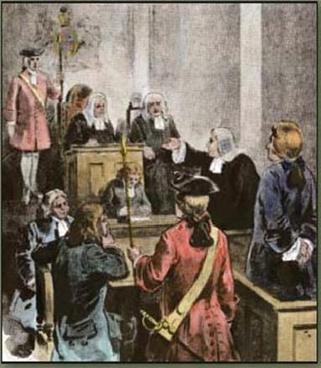

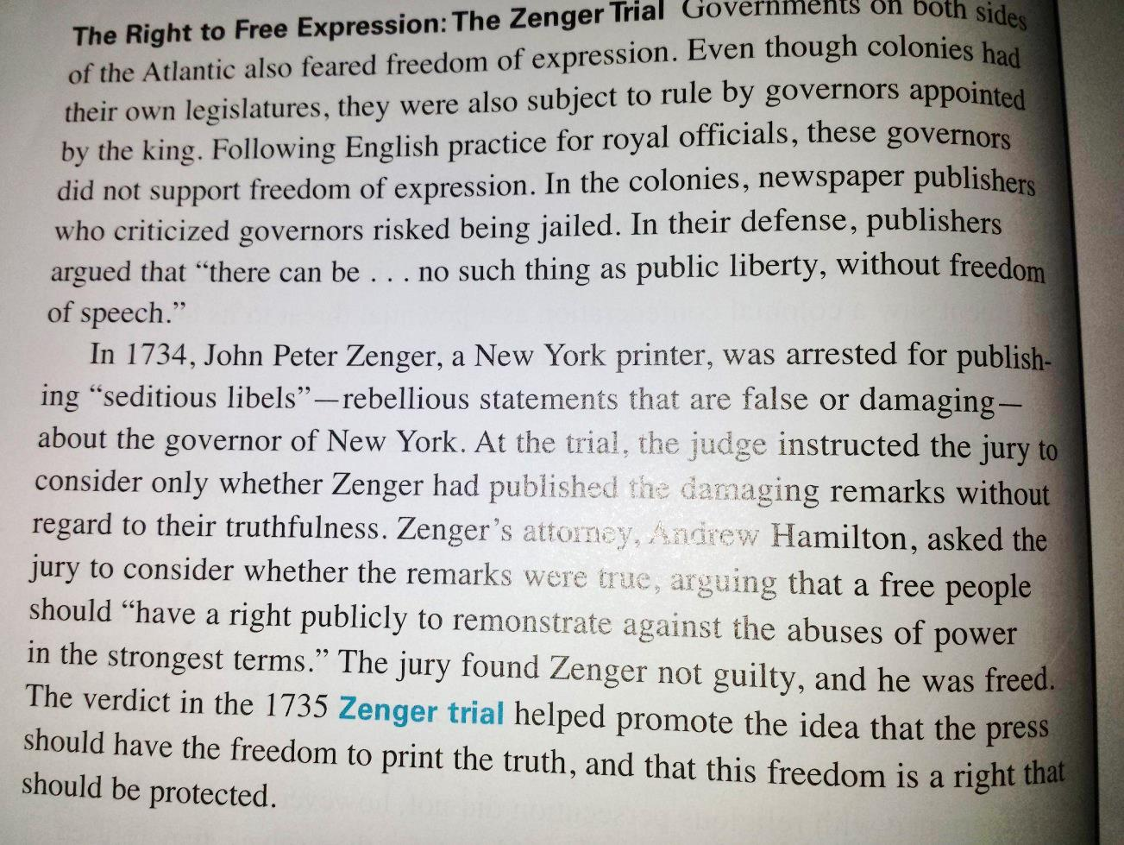

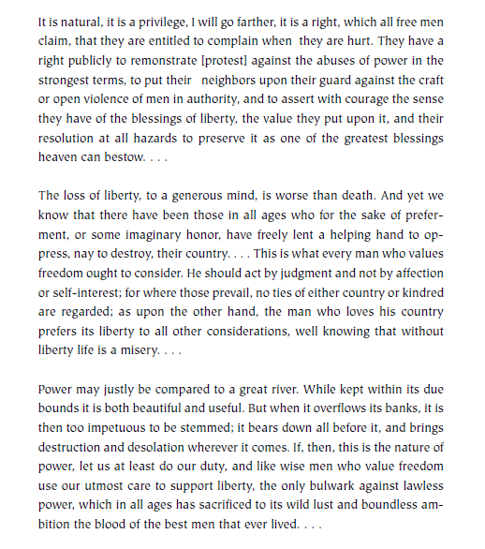
Hamilton’s Closing Arguments in the Zenger Trial

