Stamp Act DBQ Rubric
“[The Stamp Act], however justifiable it may have been in fiscal terms, posed such a distinct threat to Americans’ liberties and the autonomy of their legislatures that they could no longer contain their opposition within the traditional channels of complaints and lobbying.”  --The American Revolution (p.28) | 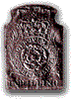  Tax Stamp, circa 1766
Why were Americans so outraged by the Stamp Act, which seemed to be a simple attempt to raise money for the crown? In what ways did they voice their opposition to the act?

I: Introduction/Thesis:
- Provides context/interesting opening to the essay
- Illustrates a specific thought, rather than merely repeating the question.
- Answers the question directly (often by identifying key phrases / verbs in the question)
- Drives the essay by providing a framework for the student’s entire argument

II: Body Paragraph #1:
- Topic Sentence is direct and effective
- Develop an aspect of one’s thesis and connect back to that thesis.
- Utilizes both the documents and knowledge gained from the readings and class
- Conclusion of the paragraph links back to the thesis and transitions to the next paragraph

II: Body Paragraph #2:
- Topic Sentence is direct and effective
- Develop an aspect of one’s thesis and connect back to that thesis.
- Utilizes both the documents and knowledge gained from the readings and class
- Conclusion of the paragraph links back to the thesis and transitions to the next paragraph

III: Inclusion of Documents / Quotations:
- Proper Citation: …the Stamp Act” (Document B).
    - Quotations are introduced: Franklin argues, “[quotation.]”
- Quotations / Documents should have their significance illustrated.

IV: Conclusion:
- Conclusions should review the material and provide a final interesting thought

- Document A: Engraving of Attack on Tax Collector

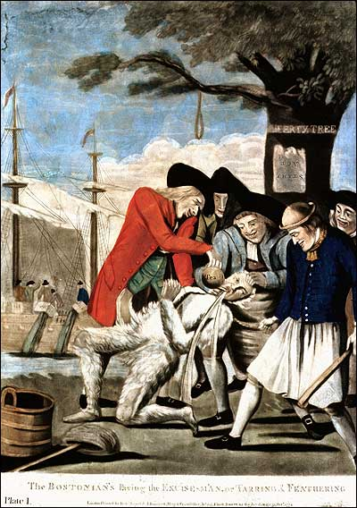

(note: a sign on the tree says “Liberty Tree” and the Stamp Act hangs upside down)

- Document B: Excerpts from Virginia Stamp Act Resolutions (30 May 1765)

Resolved, that by two royal charters, granted by King James I, the colonists aforesaid are declared entitled to all liberties, privileges, and immunities of denizens and natural subjects to all intents and purposes as if they had been abiding and born within the Realm of England.

Resolved, that the taxation of the people by themselves, or by persons chosen by themselves to represent them, who can only know what taxes the people are able to bear, or the easiest method of raising them, and must themselves be affected by every tax laid on the people, is the only security against a burdensome taxation, and the distinguishing characteristic of British freedom, without which the ancient constitution cannot exist.

- Document C: Excerpts from a Letter from Archibald Hinschelwood, A British Sympathizer Living in Massachusetts (June 1765)

There is a violent spirit of opposition raised on the continent against the execution of the Stamp Act, the mob in Boston have carried it very high against the Secre[tar]y [Andrew Oliver]...for his acceptance of an office in consequence of that Act. They have even proceeded to sow violence, and burnt him in effigy. They threaten to pull down & burn the stamp office row building; and that they will hold every man as infamous that shall presume to carry the Stamp Act into execution, so it is thought Mr. Oliver will resign.

- Document D: Excerpts from Stamp Act Congress Resolutions (October 1765)

II. That His Majesty's liege subjects in these colonies, are entitled to all the inherent rights and liberties of his natural born subjects within the kingdom of Great-Britain.
III. That it is inseparably essential to the freedom of a people, and the undoubted right of Englishmen, that no taxes be imposed on them, but with their own consent, given personally, or by their representatives.
VIII. That the late Act of Parliament, entitled An Act for granting and applying certain stamp duties, and other duties, in the British colonies and plantations in America, etc., by imposing taxes on the inhabitants of these colonies, and the said Act, and several other Acts, by extending the jurisdiction of the courts of Admiralty beyond its ancient limits, have a manifest tendency to subvert the rights and liberties of the colonists.

IX. That the duties imposed by several late Acts of Parliament, from the peculiar circumstances of these colonies, will be extremely burthensome and grievous; and from the scarcity of specie, the payment of them absolutely impracticable.
XIII. That it is the right of the British subjects in these colonies, to petition the King, Or either House of Parliament.

- Document E: William Pitt’s (A member of Britain’s Parliament) Protest Against the Stamp Act on Behalf of the Colonies (6 June 1766)
If [the British government] does not understand the difference between external and internal taxes, I cannot help it; but there is a plain distinction between taxes levied for the purpose of raising a revenue, and duties imposed for the regulation of trade, for the accommodation of the subject; although, in the consequences, some revenue might incidentally arise from the latter.
The gentleman asks, when were the colonies emancipated? But I desire to know, when were they made slaves. …I will be bold to affirm, that the profits to Great Britain from the trade of the colonies, through all its branches, is two millions a year. This is the fund that carried you triumphantly through the last war....

- Document F: Excerpts from the Declaratory Act (March 1766)

That the said colonies and plantations in America have been, are, and of right ought to be, subordinate unto, and dependent upon the imperial crown and Parliament of Great Britain; and that the king's Majesty, by and with the advice and consent of the Lords Spiritual and Temporal, and Commons, of Great Britain, in Parliament assembled, had, has, and of right ought to have, full power and authority to make laws and statutes of sufficient force and validity to bind the colonies and people of America, subjects of the crown of Great Britain, in all cases whatsoever.

