United States History
2013-2014 Syllabus
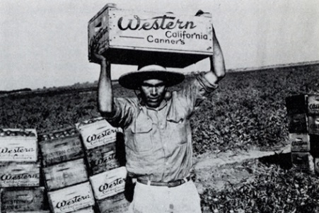
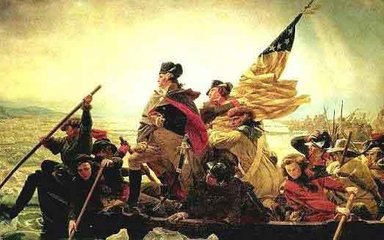
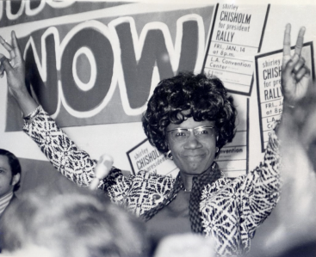

Welcome to your Junior Year! I hate to break it to you but it’s probably the hardest. Whenever you’re considering giving in and binge watching Americas Next Top Model instead of studying for SATS… remember… next year you will be relaxing with your college acceptance letters and it will all be worth it!

Fall Term Class Description:
United States history in the fall term focuses upon events leading up to the Revolutionary War through the War of 1812. The term is divided into three units. In the first, students will examine the settlement of the colonies and the circumstances that led to the Revolution. Secondly, students will study the war and the formation of the United States, culminating in the ratification of the Constitution. Finally, students will study the debate over federalism and the War of 1812

Required Reading:

Brinkley, Alan. The Unfinished Nation: A Concise History of the American People: Volume 1: To 1877 (Fifth Edition). Boston: McGraw Hill, 2008.

Morgan, Edmund S. The Birth of the Republic, 1763-89 (Third Edition). Chicago: University of Chicago Press, 1992.

Additionally, students will be assigned a variety of primary documents and secondary sources.

Basic Timeline for Full Year:

Fall:
Pre-Columbian Native American Civilizations
Colonial History
Revolution
Building a New Nation
The War of 1812
Winter:
The Presidency of Jefferson
The Jacksonian Era
Sectionalism
The Civil War
Reconstruction Era
The Gilded Age
*Research Paper Focus!
Spring:
The 20th Century
The Progressive era
World War One and the Twenties
The Depression and World War Two
Civil Rights Movements
The Cold War
The 21st Century

This is just a preliminary outline, the timeline may shift.

Skills:
In addition to the subject matter, students will work on developing their reading, writing, and speaking skills, expanding their ability to think critically, and formulating coherent arguments. In particular, the Peddie History department and the American History team have identified the following as skills upon which students in the fall of their Junior year will focus:

- Annotating readings
- Analyzing primary source materials
- Applying primary source analysis to historical questions
- Creating timelines
- Identifying key terms
- Fashioning coherent, well-organized paragraphs and essays
- Developing strong thesis statements and topic sentences
- Identifying significant historical locations (i.e. mapping)

Weebly Student Website:
In the first week of school we will all create student websites on a Weebly program designed for education. Your site will be password protected and only accessible to our class and your parents/guardians. I will assign you an address, and you will have the option to design and structure the site to fit your preferences. We will use the websites for current event blogs, warm-ups, group projects, timelines etc. Therefore you will be required to have certain tabs in your site. I will hand out a specific rubric with all the necessary components.

Classroom Guidelines:
Among Peddie School’s core values is respect. Students will demonstrate this value in the classroom in the following ways:
- Adhere to History Department Academic Honesty Guidelines.
- Listen to fellow classmates and do not belittle anyone’s ideas. You may, of course, disagree with one another, but always do so in a constructive manner.
- Contribute to class and small group discussions. We all need to learn from each other, and your ideas and input are important to this class.
- Turn cell phones off or to vibrate. No texting during class.
- Arrive to class on time and prepared with proper attire, completed homework, and due assignments ready to be turned in. Late assignments will not receive full credit. (Assignments printed after class has begun are LATE!)
- Take responsibility for missed notes, assignments, and assessments. If you miss class for any reason, it is your responsibility to get notes from a fellow student, to turn in assignments upon your return, and to contact me about rescheduling any missed assessments. (In the event of an extended absence, appropriate time will be given to the student to make up work.)

Grading:
Students will be graded based on the following:
- Class Participation
Students will demonstrate class participation through answering questions, contributing to daily discussions, and participating actively in in-class group work.
- Tests
There will be three (2) unit tests in the fall and a final exam.
- DBQs
Primary source materials are integral to the study of history. Students will learn how to assess and use primary source documents to answer Document-Based Questions this term.
- Homework Checks
Active class participation depends upon preparation at home. Students are subject to various types of unannounced homework checks to ensure that they are preparing thoroughly for class. These may include homework quizzes, focus question checks, annotation checks, or homework collection. Homework checks include your current event blog.
- Quizzes/Pop-quizzes

If You Need to See Me:
- You can usually find me in EDIT or in the EDIT during my free periods:
  - Monday: B, D, C
  - Tuesday: G, B
  - Wednesday: D, G
  - Thursday: B, D
  - Friday: G, B, C
  - Saturday: D

- Below is my Contact Information. Email is always easiest
  - Email: sgraefe@peddie.org
  - Cell: 215 589 9463
  - Twitter: @MsGraefe

- If you want to come see me at home, feel free, but it is probably a good idea to call first to make sure I’m available. My apartment is in Roberson across for the History Building. This offer to drop by does not hold for when Doctor Who is on TV.

